NUMBER THEORY

## Unit 1: Finding Equivalent Fractions

## Grade 5

**Deb Murphy – Hill City Middle School** [**dmurphy@isd002.org**](mailto:dmurphy@isd002.org)

**Peter Bahr – Lincoln – Bemidji** [**Peter_Bahr@bemidji.k12.mn.us**](mailto:Peter_Bahr@bemidji.k12.mn.us)

# Executive Summary

UNIT 1: Finding Equivalent Fractions

Learning Goals:

The students will be able to:

* recognize and generate equivalent fractions using the multiplier or divisor method
* identify and generate the greatest common factor of chosen numbers – either using the list method, crazy method, or prime factorization method.
* identify and the prime factorization of a number
* simplify fractions using the common factor methods.
* compare fractions using common denominators.

Minnesota Standards:

Numbers and Operation

Read, write, represent and compare fractions and decimals; recognize and write equivalent fractions; convert between fractions and decimals; use fractions and decimals in real-world and mathematical situations.

5.1.2.4

Recognize and generate equivalent decimals, fractions, mixed numbers and improper fractions in various contexts.

The following unit includes seven lessons and numerous activities that after completion the students will have the ability to find equivalent fractions. We concentrated mainly on activities that include finding factors, identifying the greatest common factor, and divisibility rules that will lead them to that goal.

They may find problems such as these on the MCA III test:

EXAMPLE#1: Valerie made 1 lb. of pizza dough. She cut the whole into 12 pieces and then placed it into packages. She sold one package and had 5/6 of the whole left. She sold another package and had 2/3 of the whole left. How much does the dough in each package weigh? How many packages were made?

EXAMPLE#2: Alyssa said that 6/8 and 9/12 are not equivalent because there is no whole number you can multiply both parts of 6/8 by to get 9/12. Is she correct?

EXAMPLE#3: Meg and Marcus are making a latch hook rug. So far, Meg has finished 2/5 of the rug, and Marcus has finished ¼. What fraction of the rug have they completed?

# Table of Contents:

Pretest Page 4

Launch Story:

Polar Bear Math – Learning about Fractions with Klondike and Snow. Page 4

Lesson 1 - Explain Equivalent Fractions Pages 5

Lesson 2: Using Pattern Blocks to Identify Equivalent Fractions Page 6

Lesson 3 - Using the Multiplication Table to Find Equivalent Fractions Page 6

Lesson 4 – Divisibility Rules Pages 8-17

Activity - Divisibility Rules by Andrea Kerr (9-21-11) Page 18

Activity – 100 Locker Problem Pages 18-19

Activity – Factor Game Page 19

Prime Factorization Chart Page 19

Lesson 5 – Greatest Common Factor – List Method Page 20

Greatest Common Factor – Prime Factorization Tree Method Page 21

Secret Code - Scientific Notation of Prime Factorization Page 22

Great Common Factor – “Crazy Method” Upside Down Division Page 22-24

Lesson 6 – Link Methods and Summarize Concepts Games and Activities Page 24

Post Test Page 24

Unit Analysis and Reference Notes for the Future Page 25

# Unit 1 – Finding Equivalent Fractions

**DAY 1:**

**PRETEST**

Name _______________________________

**Entrance Slip –**

**Big Idea #1 – Equivalent Fractions**

1. Write a fraction equivalent to using the multiplier method.

2. Write a fraction equivalent to . __________________

3. Simplify using the greatest common factor $\frac{12}{16}$

_______________

Use common denominators to compare. Use , , or =.

4. 5. 6.

**LAUNCH: Read the story “Polar Bear Math – Learning about Fractions with Klondike and Snow”**

**Authors: Anne Whitehead Nagda and Cindy Bickel**

#### **Lesson 1:** **Explain Equivalent Fractions**

#### **(Day 2)**

**Explore** – Activity 1. Use Number Line/Fraction Sticks to explore equivalent fractions.

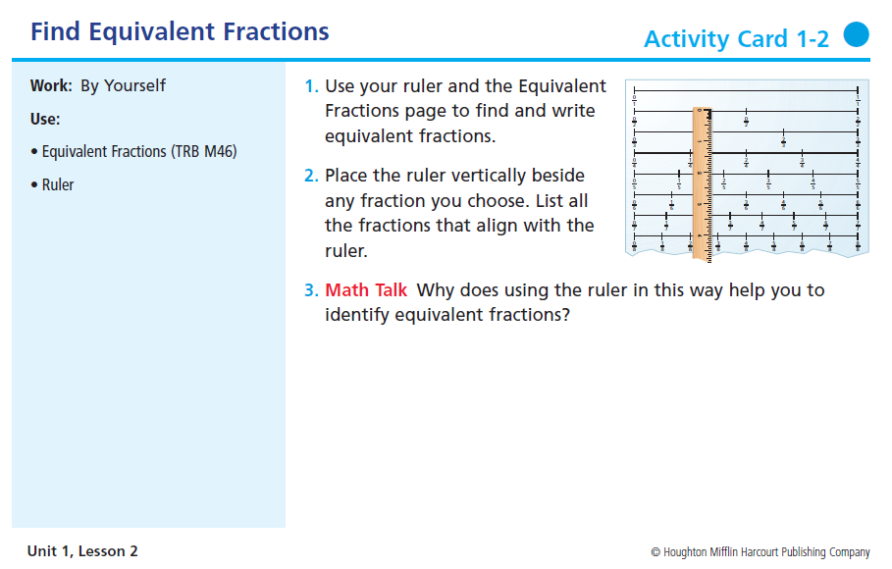

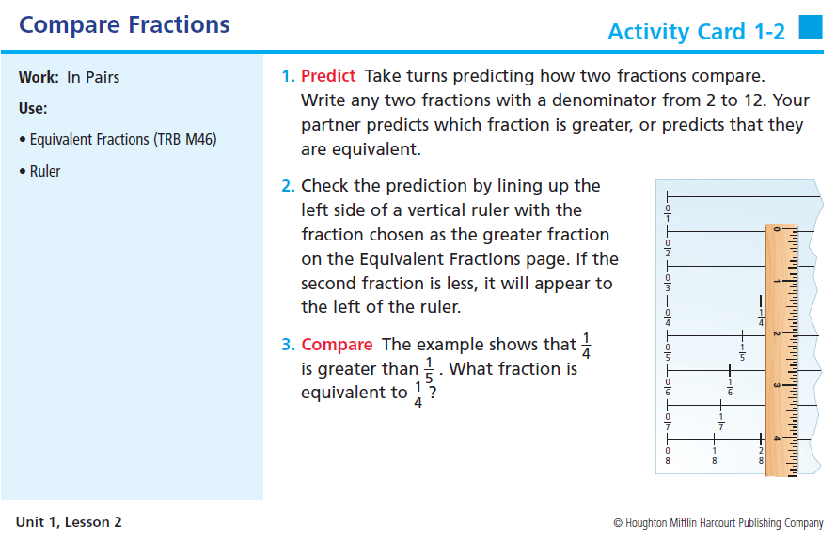

**Share – Model at the board their method of comparing and finding equivalent fractions.**

**Summarize – What did you discover?**

#### **Lesson 2:** **Explain Equivalent Fractions**

#### **(Day 3)**

**Explore** – Activity 1. Use Pattern Blocks to explore equivalent fractions.

Use Pattern Blocks SMART Board Lesson

Interactive Site: Allows discovery of equivalent fractions using pattern blocks found at [illuminations@nctm.org](mailto:illuminations@nctm.org) Pattern Blocks

**Share – Model at the board their method of comparing and finding equivalent fractions.**

**Summarize – What did you discover?**

#### **Lesson 3: Equivalent Fractions and Multipliers (day 4)**

LAUNCH:

EXPLORE: Students will find equivalent fractions using a nonzero multiplier.

http://www.mathgoodies.com/lessons/fractions/images/eq_example4.gif

http://www.mathgoodies.com/lessons/fractions/images/eq_example4a.gif

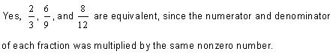

**Summarize:**

**Could we use this same principle to make a fraction into its simplest form?**

Illicit the answer that since multiplication and division are inverse operation, to simplify a fraction to simplest form both the numerator and the denominator have to be divided by the same nonzero number. This division process needs to be continued until the numerator and denominator are relatively prime (There only common factor being 1.).

**EXPLORE ACTIVITY: Use the multiplication table to find equivalent fractions.** 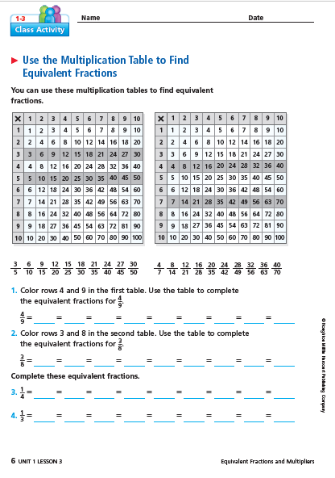

**Share – Students will model and explain the use of the multiplication chart to identify equivalent fractions.**

**Summarize** – What did you discover? What patterns did you see? Make sure to model

Elicit the procedure: that the numerator and denominator must be multiplied by the same nonzero number.

http://www.mathgoodies.com/lessons/fractions/images/eq_example4.gif

http://www.mathgoodies.com/lessons/fractions/images/eq_example4a.gif



**Could we use this same principle to make a fraction into its simplest form?**

Illicit the answer that since multiplication and division are inverse operation, to simplify a fraction to simplest form both the numerator and the denominator have to be divided by the same nonzero number. This division process needs to be continued until the numerator and denominator are relatively prime (There only common factor being 1.).

#### Lesson 4: Divisibility Rules (days 5-9)

**ACTIVITY 1**

LAUNCH / EXPLORE

https://lh4.googleusercontent.com/MSsDLf81kNHphPJ_9kBHfNunmaBEtrGkBIKfGvGB2jufW22t88euMBF-IbEJUYTe1BGOWhLuISB69baJJjSpK1p8d633oNPDw0l9VO8z4b-PcZNWUHIuSGFJDd3NV8RfHUoVM8q1_s-5jF8Lhttps://lh4.googleusercontent.com/JTgXPIAr65wXQOTLJjrRDo8wz1L3SbXYIX4BqXI7UV1yyErYTep17cfopkqB5hZsVEFokmK4gjzIOLXw4Cf5FpZvhI69_2GD18w3TydtlcAQoMGLpPw55oPfY4szSVg9Sxv7azbDnEz5KPGp

Give the following prompts to your students and allow about 10 minutes of discussion. Can you?

* Create a five digit number that is divisible by 2, 5, and 10.
* Create a five digit number that is divisible by 2, but not 5 or 10.
* Can you create a number that is divisible by 5, but not by ten?

Spend a couple of minutes discussing the math prompts from above. Now have the students discuss what they know about divisibility of numbers.

Go through each of the divisibility rules. Have the students make a foldable of the rules for 2, 3, 4, 5, 6, 8, 9, and 10. Here is a link on how to create a foldable for student note-taking. http://www.fortheloveofteachingmath.com/2011/09/21/divisibility-rules/

The students have a set of sheets where they must show what they know about divisibility rules. You can assign them all to the students and let them work together in small groups, or assign one to each group.

After the students have had ample time working with the divisibility rules activity sheets, discuss their findings.

Challenge for them to try to devise a plan for determining the divisibility rules for seven. This is the most difficult of all rules, so you may want to have some students just research the rule and test it out. How you handle this challenge would depend on the level of your students. It would also be appropriate to use calculators for some of the rules, like 8 and 9.

Divisibility Rule for 7:

If you double the last digit and subtract it from the rest of the number and the answer is 0 or a # divisible by 7, then the whole number is divisible by 7. You can apply this rule again if needed.

MAKE A STUDENT SET OF THE FOLLOWING:

https://lh4.googleusercontent.com/MSsDLf81kNHphPJ_9kBHfNunmaBEtrGkBIKfGvGB2jufW22t88euMBF-IbEJUYTe1BGOWhLuISB69baJJjSpK1p8d633oNPDw0l9VO8z4b-PcZNWUHIuSGFJDd3NV8RfHUoVM8q1_s-5jF8Lhttps://lh4.googleusercontent.com/JTgXPIAr65wXQOTLJjrRDo8wz1L3SbXYIX4BqXI7UV1yyErYTep17cfopkqB5hZsVEFokmK4gjzIOLXw4Cf5FpZvhI69_2GD18w3TydtlcAQoMGLpPw55oPfY4szSVg9Sxv7azbDnEz5KPGp

How do you know if a number is divisible by 2? Rule:

Are these numbers divisible by 2? Circle the ones that are divisible by 2.

21 28 45 36 68 72 79 88 54 32 87 91

44 27 35 62 239 428 323 634 241 235 845 1,247

2,358 3,357

**Written Response:**

Explain why the numbers circled above are all divisible by 2.

Write a 6 digit number that is divisible by 2.

Write a 7 digit number that is divisible by 2.

Write an 8 digit number that is divisible by 2.

https://lh4.googleusercontent.com/MSsDLf81kNHphPJ_9kBHfNunmaBEtrGkBIKfGvGB2jufW22t88euMBF-IbEJUYTe1BGOWhLuISB69baJJjSpK1p8d633oNPDw0l9VO8z4b-PcZNWUHIuSGFJDd3NV8RfHUoVM8q1_s-5jF8Lhttps://lh4.googleusercontent.com/JTgXPIAr65wXQOTLJjrRDo8wz1L3SbXYIX4BqXI7UV1yyErYTep17cfopkqB5hZsVEFokmK4gjzIOLXw4Cf5FpZvhI69_2GD18w3TydtlcAQoMGLpPw55oPfY4szSVg9Sxv7azbDnEz5KPGp

How do you know is a number is divisible by 3? Rule:

Are these numbers divisible by 3? Circle the ones that are divisible by 3.

21 28 45 36 68 72 79 88 54 32 87 91

44 27 35 62 239 428 323 634 241 235 845 1,247

2,358 3,357

**Written Response:**

Explain why the numbers circled above are all divisible by 3.

Write a 6 digit number that is divisible by 3.

Write a 7 digit number that is divisible by 3.

Write an 8 digit number that is divisible by 3.

https://lh4.googleusercontent.com/MSsDLf81kNHphPJ_9kBHfNunmaBEtrGkBIKfGvGB2jufW22t88euMBF-IbEJUYTe1BGOWhLuISB69baJJjSpK1p8d633oNPDw0l9VO8z4b-PcZNWUHIuSGFJDd3NV8RfHUoVM8q1_s-5jF8Lhttps://lh4.googleusercontent.com/JTgXPIAr65wXQOTLJjrRDo8wz1L3SbXYIX4BqXI7UV1yyErYTep17cfopkqB5hZsVEFokmK4gjzIOLXw4Cf5FpZvhI69_2GD18w3TydtlcAQoMGLpPw55oPfY4szSVg9Sxv7azbDnEz5KPGp

How do you know a number is divisible by 4? Rule:

Are these numbers divisible by 3? Circle the ones that are divisible by 4.

235 428 323 634 241

239 845 1,247 2,358 3,357

2,128 4,536 6,872 7,988

**Written Response:**

Explain why the numbers circled above are all divisible by 4.

Write a 6 digit number that is divisible by 4.

Write a 7 digit number that is divisible by 4.

Write an 8 digit number that is divisible by 4.

https://lh4.googleusercontent.com/MSsDLf81kNHphPJ_9kBHfNunmaBEtrGkBIKfGvGB2jufW22t88euMBF-IbEJUYTe1BGOWhLuISB69baJJjSpK1p8d633oNPDw0l9VO8z4b-PcZNWUHIuSGFJDd3NV8RfHUoVM8q1_s-5jF8Lhttps://lh4.googleusercontent.com/JTgXPIAr65wXQOTLJjrRDo8wz1L3SbXYIX4BqXI7UV1yyErYTep17cfopkqB5hZsVEFokmK4gjzIOLXw4Cf5FpZvhI69_2GD18w3TydtlcAQoMGLpPw55oPfY4szSVg9Sxv7azbDnEz5KPGp

How do you know a number is divisible by 5? Rule:

Are these numbers divisible by 5? Circle the ones that are divisible by 5.

235 428 320 634 241 239 845 1,247 2,355 3,357

2,128 4,536 6,872 7,980

**Written Response:**

Explain why the numbers circled above are all divisible by 5.

Write a 6 digit number that is divisible by 5.

Write a 7 digit number that is divisible by 5.

Write an 8 digit number that is divisible by 5.

https://lh4.googleusercontent.com/MSsDLf81kNHphPJ_9kBHfNunmaBEtrGkBIKfGvGB2jufW22t88euMBF-IbEJUYTe1BGOWhLuISB69baJJjSpK1p8d633oNPDw0l9VO8z4b-PcZNWUHIuSGFJDd3NV8RfHUoVM8q1_s-5jF8Lhttps://lh4.googleusercontent.com/JTgXPIAr65wXQOTLJjrRDo8wz1L3SbXYIX4BqXI7UV1yyErYTep17cfopkqB5hZsVEFokmK4gjzIOLXw4Cf5FpZvhI69_2GD18w3TydtlcAQoMGLpPw55oPfY4szSVg9Sxv7azbDnEz5KPGp

How do you know a number is divisible by 6? Rule:

Are these numbers divisible by 6? Circle the ones that are divisible by 6.

235 228 323 636 390 845 241 2,128 4,536

2,247 6,872 2,358 7,988 3,357

**Written Response:**

Explain why the numbers circled above are all divisible by 6.

Write a 6 digit number that is divisible by 6.

Write a 7 digit number that is divisible by 6.

Write an 8 digit number that is divisible by 6.

https://lh4.googleusercontent.com/MSsDLf81kNHphPJ_9kBHfNunmaBEtrGkBIKfGvGB2jufW22t88euMBF-IbEJUYTe1BGOWhLuISB69baJJjSpK1p8d633oNPDw0l9VO8z4b-PcZNWUHIuSGFJDd3NV8RfHUoVM8q1_s-5jF8Lhttps://lh4.googleusercontent.com/JTgXPIAr65wXQOTLJjrRDo8wz1L3SbXYIX4BqXI7UV1yyErYTep17cfopkqB5hZsVEFokmK4gjzIOLXw4Cf5FpZvhI69_2GD18w3TydtlcAQoMGLpPw55oPfY4szSVg9Sxv7azbDnEz5KPGp

How do you know a number is divisible by 8? Rule:

Are these numbers divisible by 8? Circle the ones that are divisible by 8.

235 228 323 390 845 2,128 4,536 631 636 241

2,247 6,872 2,358 7,988 3,357

**Written Response:**

Explain why the numbers circled above are all divisible by 8.

Write a 6 digit number that is divisible by 8.

Write a 7 digit number that is divisible by 8.

Write an 8 digit number that is divisible by 8.

https://lh4.googleusercontent.com/MSsDLf81kNHphPJ_9kBHfNunmaBEtrGkBIKfGvGB2jufW22t88euMBF-IbEJUYTe1BGOWhLuISB69baJJjSpK1p8d633oNPDw0l9VO8z4b-PcZNWUHIuSGFJDd3NV8RfHUoVM8q1_s-5jF8Lhttps://lh4.googleusercontent.com/JTgXPIAr65wXQOTLJjrRDo8wz1L3SbXYIX4BqXI7UV1yyErYTep17cfopkqB5hZsVEFokmK4gjzIOLXw4Cf5FpZvhI69_2GD18w3TydtlcAQoMGLpPw55oPfY4szSVg9Sxv7azbDnEz5KPGp

How do you know a number is divisible by 9? Rule:

Are these numbers divisible by 9? Circle the ones that are divisible by 9.

135 428 324 634 241

239 405 1,247 2,358 3,357

2,128 4,536 6,876 2,988

**Written Response:**

Explain why the numbers circled above are all divisible by 9.

Write a 6 digit number that is divisible by 9.

Write a 7 digit number that is divisible by 9.

Write an 8 digit number that is divisible by 9.

https://lh4.googleusercontent.com/MSsDLf81kNHphPJ_9kBHfNunmaBEtrGkBIKfGvGB2jufW22t88euMBF-IbEJUYTe1BGOWhLuISB69baJJjSpK1p8d633oNPDw0l9VO8z4b-PcZNWUHIuSGFJDd3NV8RfHUoVM8q1_s-5jF8Lhttps://lh4.googleusercontent.com/JTgXPIAr65wXQOTLJjrRDo8wz1L3SbXYIX4BqXI7UV1yyErYTep17cfopkqB5hZsVEFokmK4gjzIOLXw4Cf5FpZvhI69_2GD18w3TydtlcAQoMGLpPw55oPfY4szSVg9Sxv7azbDnEz5KPGp

How do you know a number is divisible by 10? Rule:

Are these numbers divisible by 10? Circle the ones that are divisible by 10.

235 420 323 635 241 240 845 1,240 2,358 3,000

2,128 4,536 6,872 7,960

**Written Response:**

Explain why the numbers circled above are all divisible by 10.

Write a 6 digit number that is divisible by 10.

Write a 7 digit number that is divisible by 10.

Write an 8 digit number that is divisible by 10.

**Share – Students will share the rule they identified for each number!**

**Summarize – Did we all use the say methods? Did we arrive at the same rule for each target divisor? How may this help us in math?**

**ACTIVITY #2**

(Day 10)

**Fortheloveofteachingmath.com**

**Divisibility Rules**

**By Andrea Kerr 9-21-11**

**ACTIVITY #3**

100 Locker Problem

Ongoing Project – to be worked on throughout the unit.

This project is to help students identify factor pairs, prime and composite numbers, perfect square and square roots, and other patterns with numbers. It also helps them to understand that 1 is a “special” number that has only one factor – which begins to identify a unit fraction.

THE 100 LOCKER PROBLEM

[*September 16, 2010*](https://teachtoinspire.wordpress.com/2010/09/16/the-100-locker-problem/)

This is probably one of the best math problems I give my fifth grade students. It goes like this:

There are 100 lockers in the long front hall of our school. Each August, the custodians add a fresh coat of paint to the lockers and replace any of the broken number plates. The lockers are numbered from 1 to 100.

When the students arrive on the first day, they decide to celebrate the start of the school year with our school tradition. The**first** student inside runs down the hall opening all of the lockers. The **second** student runs down the hall closing every second locker, beginning with locker number 2. The **third**student reverses the position of ever third locker, beginning with locker number 3. (If the locker is open, she closes it. If it’s closed, she opens it.) The**fourth** student changes the position of every fourth locker, beginning with number 4. This continues until the100th student has a turn, changing the position of the 100th locker.

At the **end** of this ritual, which locker doors are open?

Why are the open lockers left open?

Which patterns emerged in your work?

After a week of working on this problem with their partner, they write up what they discovered on posters. I have them include these four sections:

1. Restate the problem

2. Procedure

3. Answer

4. Check

It’s such a fun problem because at first they think it’s impossible, but by the end of the week, all the groups were able to figure it out! We **share** out our work in a “math congress” where each group presents. Also, students ask comments or give feedback to the groups that present. Here are some of their posters.

**Link to Source: Teach to Inspire** [**https://teachtoinspire.wordpress.com/2010/09/16/the-100-locker-problem/**](https://teachtoinspire.wordpress.com/2010/09/16/the-100-locker-problem/)

**Summarize: After the students share their strategies, solutions, and creations as a class identify and record the findings.**

**ACTIVITY #4**

WHAT IS A FACTOR??? Have you heard of a factor game?

(Day 11)

**Math Solutions.com**

[**http://mathsolutions.com/documents/978-1-935099-02-4_NL36_L1.pdf**](http://mathsolutions.com/documents/978-1-935099-02-4_NL36_L1.pdf)

Playing the Factor Game provides an engaging format in which students can become familiar with the factors of numbers from two to thirty by playing a two-person board game. To play Factor Game, each player chooses a number while the other player finds the sum of the available factors of that number.

**Similar interactive game can be found at illuminations.nctm.org**

**ACTIVITY #5**: PRIME FACTORIZATION CHART ACTIVITY (Day 12)

**To identify Prime Numbers – Sieve of Eratosthenes**

**Uses a 100 Number Chart and the Tell story of Eratosthenes**

**LINK:** [**www.pedagonet.com/quickies/Eratosthenes.pdf**](http://www.pedagonet.com/quickies/Eratosthenes.pdf)

**\*\* addresses the Fundamental Theorem of Arithmetic:**

**“All counting numbers greater than two can be expressed as a unique product of primes.**

Lesson 5: Greatest Common Factor – List Method (Day 13)

**Launch**: Remember that **factors** are the numbers we multiply together to get another number   
  
Example: **2 x** **9** **= 18**   
  
2 and 9 are factors of 18.  
  
When we have two or more given numbers, we can find the largest factor that both numbers have in common. This is called the **GCF** or the Greatest Common Factor.

LIST METHOD:

Step 1: List the factors of each number.   
  
64: 1, 2, 4, 8, 16, 32, 64  
  
96: 1, 2, 3, 4, 6, 8, 12, 16, 24, 32, 48, 96  
  
Step 2: Look for factors that both lists have in common.  
  
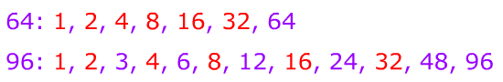  
Step 3: Pick out the largest factor that both lists have in common and call this the GCF.  
  
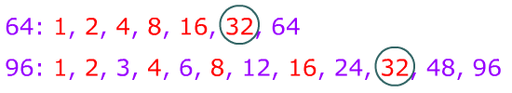  
  
Therefore, the GCF of 64 and 96 is 32.

**SHARE:** Students will model share their understanding of using the list method to identify the factors, common factors and greatest common factor of chosen numbers

Lesson 5: Greatest Common Factor using Prime Factorization Tree Method (DAY 13)

**Explore** - Prime Factorization  
  
We can also use the prime factorization of two numbers to help us get the GCF.  
  
Example: Find the GCF of 150 and 225.  
  
Step 1: Start by making factor trees for each of the numbers.  
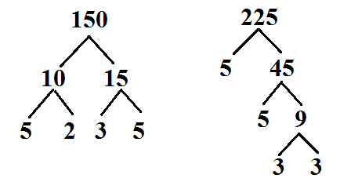  
  
Step 2: List out the prime factorization for each number.  
  
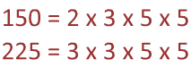  
  
Step 3: Now circle the prime factors that each number has in common.  
  
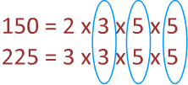  
  
Step 4: Next, multiply the circled numbers together. 3 x 5 x 5 = 75  
  
This tells us that the GCF of 150 and 225 is 75.

**Share – Students will complete sample problems on the board, sharing the strategy.**

Lesson 5:

Greatest Common Factor - Writing Prime Factorization using the Secret Code (DAY 15)

**Launch** -

**Explore** – Students will generate a prime factorization first writing it in standard notation – followed by scientific notation (THE SECRET CODE).



150 = 2 x 3 x 5^2

225 = 3^2 x 5^2

**Summarize:** Which way doo they prefer? When would this “Secret Code” be useful?

Lesson 7: Prime Factorization “Crazy Method” (DAY 16)

**Launch** – Tell an “I’m Really Lazy Story” – I like to take short cuts and get done as fast as I can. So I am a multi-tasker! I try to do more than one thing at a time? Add funny details!

**Explore** - **Method 2:** Upside Down Division Students will use this method to find the greatest common factor of a few sample problems.  
  
Find the GCF of 280 and 144.  
  
Step 1: Place the numbers inside an upside down division bar.  
  
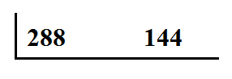  
  
Step 2: Now, we need to divide both numbers by a common factor. Because both of the numbers are even, we could start with 2.The answer goes underneath the bar.  
  
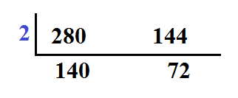  
  
Step 3: We will continue to divide until we have two numbers that are relatively prime. Remember that relatively prime means two numbers that do not have any common factors other than 1.  
  
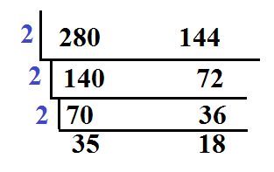  
  
35 and 18 are relatively prime – they only have a common factor of 1.   
  
Step 4: Now we take all of the factors on the side and multiply them together.  
  
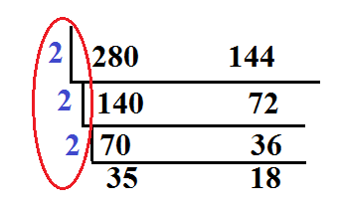  
  
2 x 2 x 2 = 8 = 2^3   
  
This means that the GCF of 280 and 144 is 8.

**Share –** Students will model and share the strategy on the board for the “Crazy Method” (Upside Down Division)

**Summarize –** In the summary after students relate this method to the others – have them use this to make a conjecture on how to use it to find the least common multiple.

Lesson 6: Link Methods & Summarize Concept (Day 17)

**Launch** – Let’s see what you’ve learned. Game Time!!

**Explore** –and then allow time for kids to explore the other options for interactive play at:

[www.math-play.com/math-fractions-games.html](http://www.math-play.com/math-fractions-games.html)

**Summarize**: As a class play Factors and Multiples Jeopardy Game; utilize the questions to summarize student learning.

**UNIT 1: POST TEST**

Name _______________________________

**Exit Slip –**

**Big Idea #1 – Equivalent Fractions**

1. Write a fraction equivalent to using the multiplier method.

2. Write a fraction equivalent to . __________________

3. Simplify using the greatest common factor $\frac{12}{18}$

Compare using a common denominator. Use, , or =.

4. 5. 6.

**Analyze:**